Originality Statement of IVC Lab final optimization

List of open source software and codes publicly available used in the final optimization work:

1. matlab 2021b deep learning tool box

2. Increase Image Resolution Using Deep Learning

https://ww2.mathworks.cn/help/deeplearning/ug/single-image-super-resolution-using-deep-learning.html

3.

…

With my/our signature(s) below, I/we assert that the final optimization work has been composed by myself/ourselves and no source materials or aids other than those mentioned above have been used.

Munich 02.19.2023



_____________________

Place, date



______________________

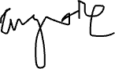

signature